ADDITIONAL SUPPORTING ACCOUNTING EVIDENCE

Below are additional pieces of evidence demonstrating the effectiveness of my stock-market methods, which produce convincing results well beyond the gold and gold-mining sector.

2007/2008 Banking Crash and Bank Stock Decline in 2018

French companies are encouraged to offer employee savings plans to their employees. I took advantage of this opportunity to subscribe to shares in Crédit Lyonnais and Crédit Agricole SA, two of my former employers. The shares were offered regularly following the privatization of Crédit Lyonnais in 1999. A 20% discount on the price was granted in compensation for illiquidity, since the shares had to be held for a period of five years. From 2004 to April 2017, the price of Crédit Agricole SA moved from €35 in 2006 to less than €3 in 2012; its current price is €15.9 (March 27, 2026) with significant dividends almost every year.
Many Casa shares were sold in 2004, 2006 and 2007, just before the banking crisis and the sharp decline in banking stocks that followed. This performance was achieved thanks to our econometric models, which correctly indicated that banking shares were overvalued end 2006,2007. Casa Shares were sold at an average price of €25.75, with a unit cost basis of €6.08 per share (origin: Crédit Lyonnais shares), generating a gain of 324% over 7 years, far above market performance.
Pages 3, 4 and 5 of Supporting Exhibit 2 illustrate the sale of funds invested exclusively in Crédit Agricole SA shares from 2004 to 2007, i.e. at prices close to the highs reached during the period.
https://drive.google.com/open?id=0B_o0_XsgC0-lUGlWbDV5cmpEYVU

Date of sale | Units sold | Sale price | Unit cost basis | Gain | Gross proceeds
01/09/2004 | 20,039 | 20.0 | 6.08 | 229% | 400,780
08/12/2004 | 10,008 | 22.5 | 6.08 | 270% | 225,180
10/07/2006 | 12,000 | 30.5 | 6.08 | 402% | 366,000
07/08/2007 | 5,734 | 27.0 | 6.08 | 344% | 154,818
09/05/2007 | 8,783 | 31.0 | 6.08 | 410% | 272,273
17/04/2007 | 7,223 | 31.0 | 6.08 | 410% | 223,913
TOTAL | 63,787 | 25.75 | 6.08 | 324%

At year-end 2007 (see page 10), the value of my company savings plan (PEE) was €52.3K, made up of €17.5K in cash and only €34.8K in Crédit Agricole SA equity funds, after sales of Crédit Agricole SA shares deemed overvalued by my models for €43.7K in 2004, 2006 and 2007.
https://drive.google.com/file/d/0B_o0_XsgC0-lR2owOWVEdm5abHc/view?usp=sharing

Page 2 of Supporting Exhibit 3 shows the unit cost basis of the Crédit Agricole SA positions rebuilt after 2008, i.e. after the crash, namely a unit cost basis ranging from €5.10 to €5.42 per share.
https://drive.google.com/file/d/0B_o0_XsgC0-lRVZpUDFucWxvRnM/view?usp=sharing

Crédit Agricole SA was worth €13.9 on April 25, 2017, and my total PEE/PERCO was valued at €160K, including €25K in PERCO, versus €52K previously.
https://drive.google.com/file/d/0B_o0_XsgC0-lcFlZeFV3OHFVaXM/view?usp=sharing

In 2017, and especially in December 2017, I sold about 70% of my holding in Crédit Agricole shares. The sales were made at €13.8 per share, generating a return of 160%, far above the market (average share cost: €5.3). Casa shares then fell by 37% in 2018, reaching a low of €5.8 during the Covid crisis in March 2020.
The average cost of €5.3 is supported by three groups of Casa shares disposed of by year-end 2017:

Holding block | Number of shares | Gross amount (€) | Gain or loss | Unit cost basis
Standard CA cost-basis block | 2,966 | 32,234 | 14,754 | 5.89
LCL shares | 2,957 | 32,143 | 17,092 | 5.09
LCL Casa shares | 275 | 2,991 | 2,658 | 1.21
TOTAL | 6,198 | 67,368 | 34,504 | 5.30

Altaprofits Retirement Savings Plan Performance

The position of this retirement plan as of March 27, 2026, originally opened to take advantage of the fiscal scheme, is as follows:

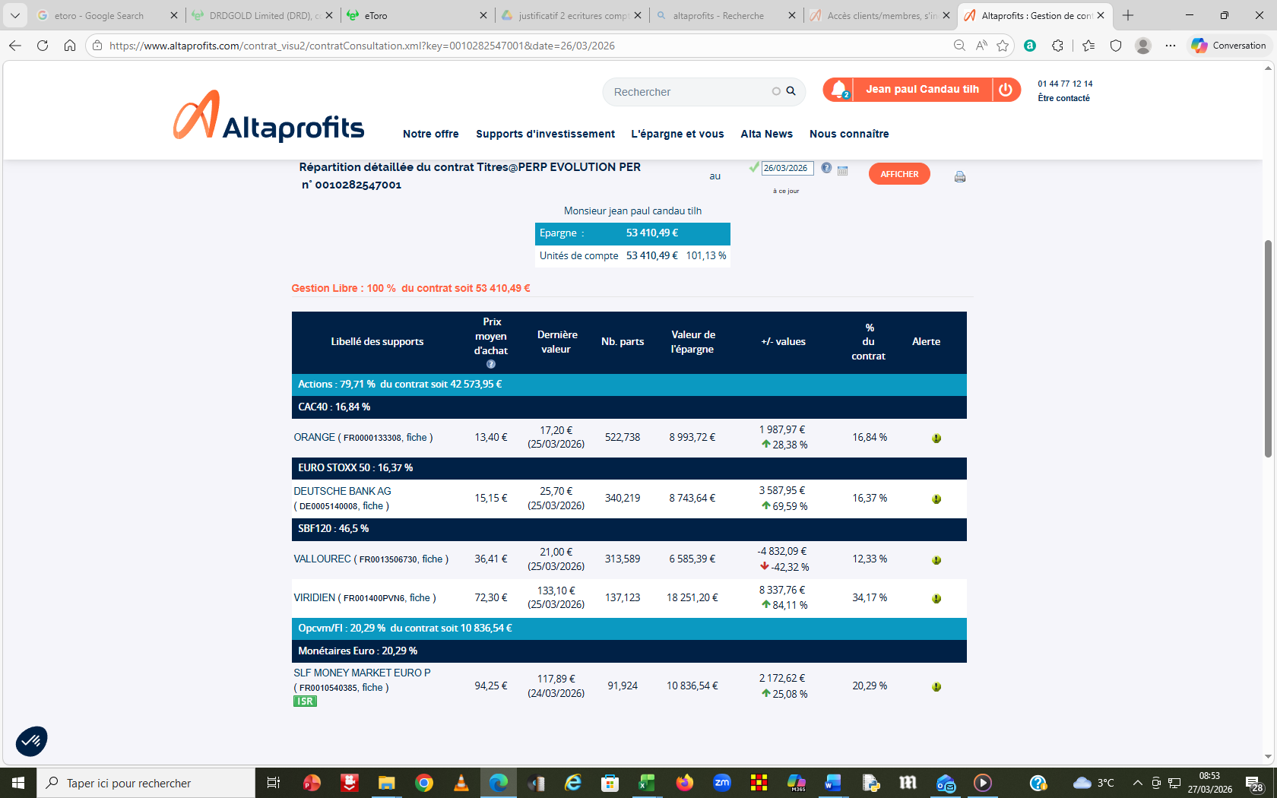

Overall, since its inception in 2017 (first purchases), it has achieved a return of 27%. With respect to Vallourec, one should take into account a position of 313 shares (broker: ETORO) with a cost basis of €12 and a current price of €21 (i.e. a value of €6,600). The return on that holding therefore improves from -42% to only -10%.
That said, the shares in this portfolio have very significantly outperformed the market since December 2024.

Prices in euros
Security / Index | 12/31/2024 | 03/26/2026 | % increase
Viridien | 50 | 137 | +174%
Vallourec | 16 | 21.4 | +34%
Deutsche Bank | 16 | 25 | +56%
Orange | 9.6 | 17.2 | +79%
Benchmark – CAC 40 | 7,300 | 7,769 | +6.4%

PEA Performance (Tax-Advantaged Equity Savings Plan)

Supporting Exhibit 4 summarizes the performance achieved in my wife’s PEA. A series of positions in French shares considered undervalued was built with my help in November 2008, a date fairly close to the low reached in March 2009. After these securities were sold, the results were as follows:

https://drive.google.com/file/d/0B_o0_XsgC0-lTnItSThhT3NYOWs/view?usp=sharing

- Alcatel: shares bought at an average of €2.1 and then sold at an average of €3.59 (return: 71%).
- Havas: shares bought at an average of €2.02 and then sold at an average of €4.86 (return: 140%).
- Rhodia: shares bought at an average of €6.04 and then sold at an average of €18.6 (return: 208%).
- Haulotte: shares bought at an average of €6.38 and then sold at an average of €7.7 (return: 20%).
- Derichebourg: shares bought at an average of €1.86 and then sold at an average of €4.8 (return: 158%; position of 1,000 shares still held today).
- Bigben Interactive: shares bought at an average of €7.3, still held today and valued at €5.5, representing a loss of 25%.

From end-2008 (3217) to April 2017 (5013), the CAC itself rose by 56%, a performance far below that recorded on my wife’s PEA.

End of document

